SHULL SCIENCE · JAMES A. GARFIELD LOCAL SCHOOLS
UNIT 2 TEST: WRITTEN
UNIT 2 TEST · DAY 2 · WRITTEN · TEACHER KEY
NAME | DATE | PERIOD | SCORE / 14

You may use a periodic table. Write every configuration in order of filling. In the orbital diagram, each electron gets one arrow.

Part 1 Longhand configurations | 8 points

Number 1 also needs its orbital diagram.
1 | 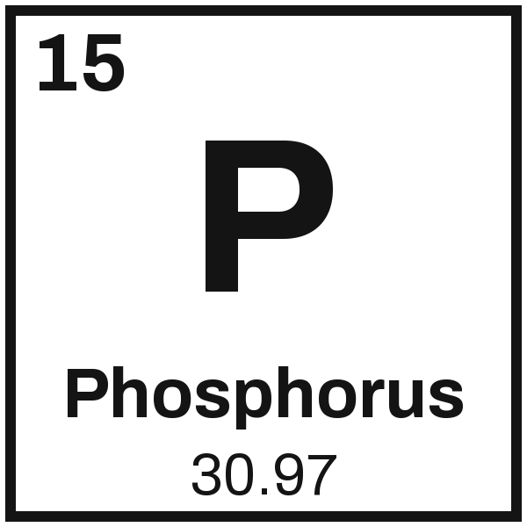 | Configuration 1s² 2s² 2p⁶ 3s² 3p³
1 |  | Orbital diagram
  1s | ↑↓ | 2s | ↑↓ | 2p | ↑↓ | ↑↓ | ↑↓ | 3s | ↑↓ | 3p | ↑ | ↑ | ↑

2 | 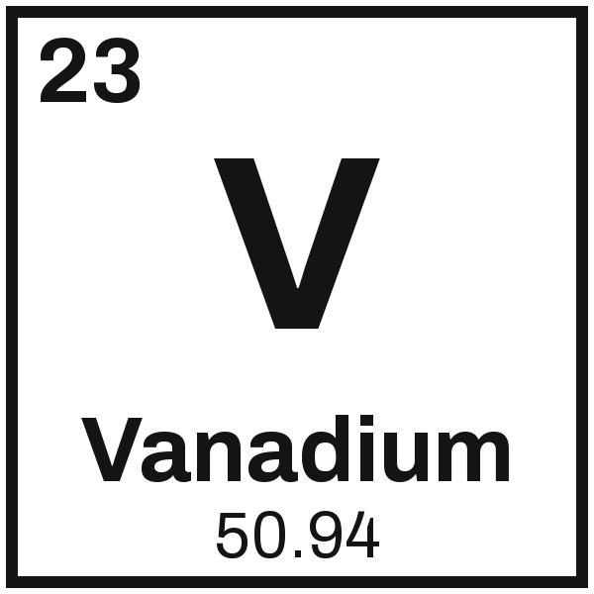 | Configuration 1s² 2s² 2p⁶ 3s² 3p⁶ 4s² 3d³

3 | 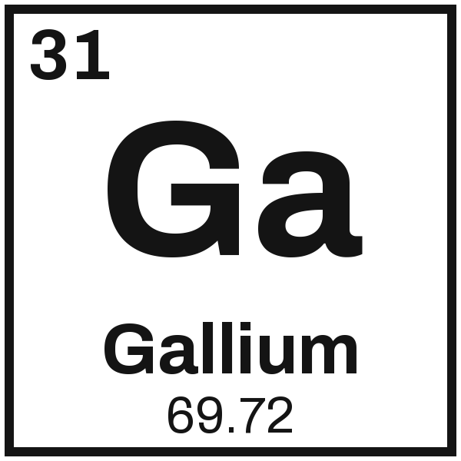 | Configuration 1s² 2s² 2p⁶ 3s² 3p⁶ 4s² 3d¹⁰ 4p¹

1 is 4 pts, configuration 2 and diagram 2 (take 1 off per rule broken). 2 and 3 are 2 pts each, 1 off for one wrong sublevel.

Part 2 Noble-gas shorthand | 6 points

4  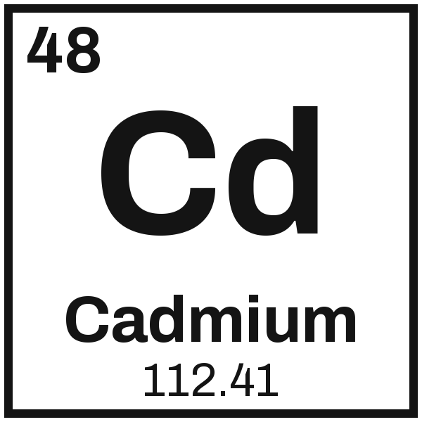 | 5  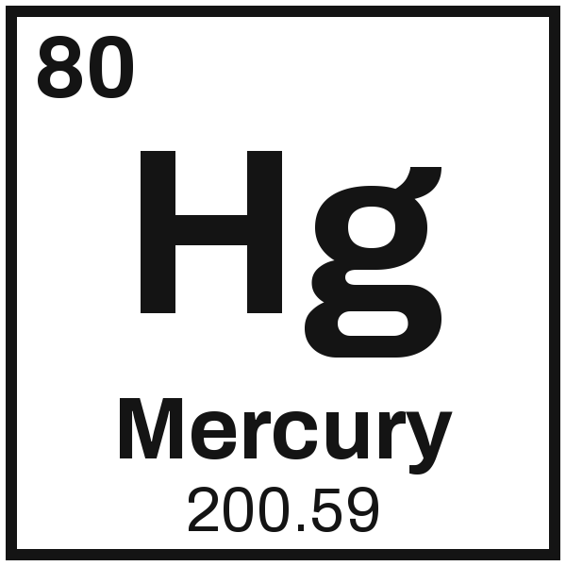 | 6  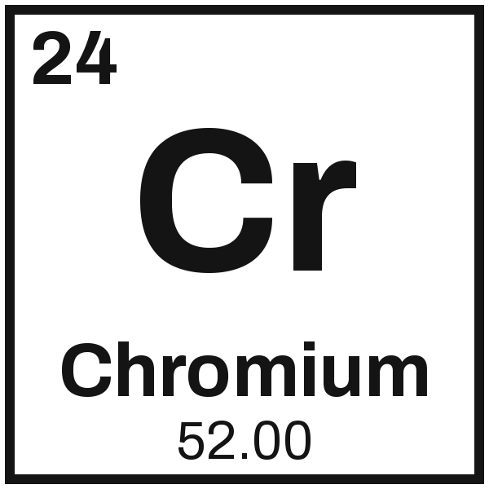
  [Kr] 5s² 4d¹⁰
  [Xe] 6s² 4f¹⁴ 5d¹⁰
  [Ar] 4s¹ 3d⁵

2 pts each, noble-gas core 1 and the rest in order 1. Chromium is the exception, so [Ar] 4s² 3d⁴ earns 1.

